Manila Water Company
technical specification - REPORT

<DID_S2P_354>

Work Accomplishment Report

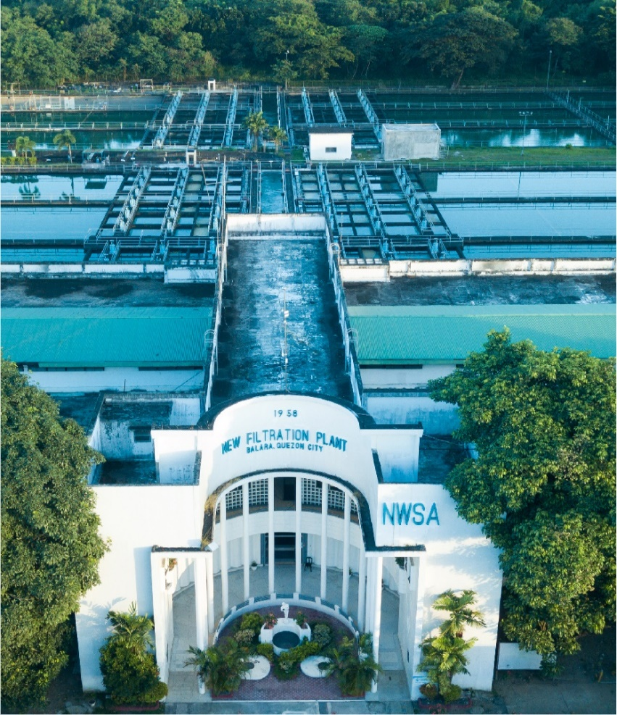



Contents
1 Document Organization 5
1.1 Document Log 5
1.2 Integration, Document Reference 5
2 Program Attributes 6
2.1 Selection Screen 6
2.2 Validation of Selection Criteria 7
2.3 CDS Views/AMDP/Table Function 7
2.3.1 Selection Condition 7
2.3.2 Join Condition 7
2.3.3 Fields 7
2.3.4 Additional Details 7
2.3.5 GIT Repository Details 7
2.4 Authorization Requirements 8
2.4.1 Definition 8
2.4.2 Defined Fields 8
2.4.3 Procedure 8
2.4.4 DCL Details 8
2.4.5 BTP Details 8
2.5 Technical Flow Diagram 8
2.6 UI Details 8
2.6.1 UI Mock Screens 8
2.6.2 Navigations 9
2.6.3 Actions 9
2.6.4 Validations 9
2.6.5 Other Details 10
2.7 Processing Logic 10
2.8 Reusable Code 10
2.9 Messages 10
2.10 Subroutines 11
3 Report Output 11
3.1 Output Method 11
3.2 Main Heading 11
3.3 Sub Heading 11
3.4 Layout / UI Design 11
3.5 Totaling 12
3.6 Sorting 12
3.7 Page Break 12
3.8 Error Handling 12
3.9 Report Header & Footer 12
4 Assumptions in Technical Design 12
5 Open Issues in Technical Design 12
6 Unit Test Results 12
7 Related Documentation 13

Document Organization
This section provides details about this document, previous version(s) of this document and the document(s) referred.

Document Log
Following table mentions the version changes and the processer(s):
Version | Status | Date | Version Created by (Name/E-Mail/Company) | Role | Comments
1.0 | Draft | August 6, 2025 | Sayyad Sarfraz Ali(sayyad.sarfraz@diligentglobal.com) | Author | Initial Draft
2.0 | Reviewed with Comments | August 6, 2025 | Pulkit Kakkar(pulkit.kakkar@diligentindia.onmicrosoft.com) | Reviewer

Integration, Document Reference

S. No. | Referred Document Name | Referred Document Version | Referred Document URL (Optional)
1 | MWC_FSD_DID_S2P_354_WAR Report | V1.1 | Attached below under Related Documentation

Program Attributes
Program title | Work Accomplishment Report
Program Name | ZAB_S2P_WORK_ACC_RPT
Program Type | Executable
Package | ZS4_MWC_S2P_MM
Authorization Group | N/A

Transaction Code | ZTR_S2P_WORK_ACC_RPT
Include Programs | ZIN_S2P_WORK_ACC_RPT_TOP  ZIN_S2P_WORK_ACC_RPT_E01  ZIN_S2P_WORK_ACC_RPT_F01

SAP Tables Read | MMPUR_SES_ITEM  MMPUR_SES_HEADER  EKKO  EKPO  EKKN  PRPS  PROJ  AFKO  LFA1  EKBE  RBKP  RSEG
Custom Indexes | N/A
CDS Views | N/A
OData Service | N/A
Business Object | N/A
Group Name | N/A
Catalog Name | N/A

Selection Screen

Validation of Selection Criteria
N/A

CDS Views/AMDP/Table Function
N/A

Selection Condition
N/A

Join Condition
N/A

Fields

N/A

Additional Details
N/A

GIT Repository Details

Development Details
GIT Location | N/A
GIT URL | N/A

Authorization Requirements
N/A

Definition
N/A

Defined Fields
N/A

DCL Details
N/A

BTP Details

xs-security Configuration | N/A
IDP Setup | N/A
BTP Role Collections | N/A

Technical Flow Diagram
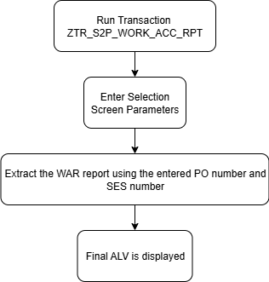

UI Details
N/A

UI Mock Screens

Application Name
Site | N/A
URL | N/A
Mockup | N/A

Navigations

Source View | Target View / URL | Pattern
N/A | N/A | N/A

Actions

Application | Screen(s) | Action | Type | Action Description
N/A | N/A | N/A | N/A | N/A

Validations
Application | Screen(s) | Field/Button | Validation Logic – Method, function details
N/A | N/A | N/A | N/A

Other Details
N/A

Processing Logic
- The program starts by fetching PO item data from the table EKPO using the provided Purchasing document number from the selection screen.
- It then reads PO account assignment data from table EKKN.
- If the PO account assignment contains a WBS element, WBS master data is fetched from PRPS, and corresponding project details are retrieved from PROJ.
- If a network/internal order (NPLNR) exists instead, the program fetches manufacturing order details from table AFKO.
- Vendor information such as name and address is retrieved from tables EKKO (PO Header) and LFA1 (Vendor Master).
- For each SES line item, PO item data including contract number, quantity, unit price, and value is pulled from EKPO.
- Previously posted SES data for the same PO item is also collected using MMPUR_SES_ITEM, excluding any SES entries that were approved status <> 30 (MMPUR_SES_HEADER).
- Each document number (BELNR) is used to fetch corresponding invoice line items from RSEG.
- Header details from RBKP are used to verify that the invoices are posted and not reversed.
- Based on SES and invoice data, various cost categories are calculated.
- Header data for the report (e.g., SES period, WAR number, contractor name, project name, extension name) is compiled for display.
- Final report data is collected into internal table.
- Display logic uses SALV (CL_SALV_TABLE) to show the report on screen.
- Aggregations are applied for cost columns.

Reusable Code
N/A

Messages
N/A

Subroutines
Name | Description
N/A
N/A
N/A

Report Output

Output Method

N/A

Main Heading

Sub Heading
N/A

Layout / UI Design
N/A

Totaling
N/A

Sorting
N/A

Page Break
N/A

Error Handling
N/A

Report Header & Footer
N/A

Assumptions in Technical Design

N/A

Unit Test Results

Scenario # | Input Selection Criteria | Expected Result | Actual Test Pass/Fail
1 | Extract the WAR report by entering the PO number and SES number | The system displays the WAR report for all service line items in the SES. | Pass

Related Documentation

